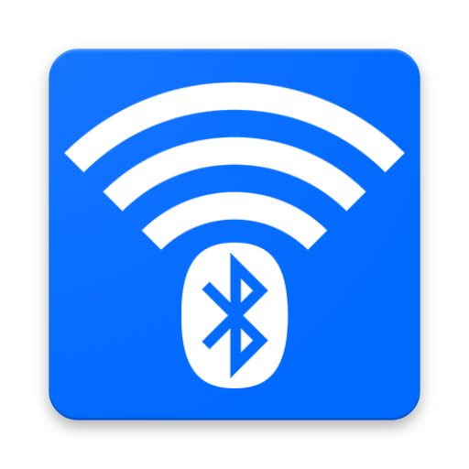

**BLUESPOT**

CHAT APP

AT&T INTERNSHIP [MAY-JUN 2018]

|  |  |  |
| --- | --- | --- |
| ACHAL SHARMA | B.Tech CSE, AMITY UNIVERSITY |  |
| AKASH TYAGI | B.Tech CSE, AMITY UNIVERSITY |  |
| SHUBHAM AGGARWAL | B.Tech CSE, AMITY UNIVERSITY |  |

**DECLARATION**

We, **ACHAL SHARMA, AKASH TYAGI, SHUBHAM AGGARWAL** students of **B.Tech. CSE** (Amity University)hereby declare that the project titled “**Bluespot: Chat App**” which is submitted by us to **MR. PETER BAKER (AT&T)** is in partial satisfaction of responsibility for the honour of the internship, which may or may not have been previously performed to acquire any award such as a degree, or other similar title of recognition.

|  |  |  |
| --- | --- | --- |
| ___________________ | ___________________ | ___________________ |
| (ACHAL SHARMA) | (AKASH TYAGI) | (SHUBHAM AGGARWAL) |

# Introduction

This app uses Bluetooth and/or Hotspot to chat with someone who is within the range of the preferred technology. Hence the name - Bluespot. The idea behind the app was to chat with someone locally when we are not able to talk for whatever reasons, it may be because you are in a class or may be in a seminar etc.

The Bluetooth mode is one-to-one messaging mode that is - one user is connected to only one user at a time. This is the basic principle of Bluetooth.

While the Hotspot Mode has a group chat system that is - there can be multiple users chatting at the same time with each other. There are options to send images, documents, emoticons etc. in both the modes. The data gets stored locally on devices and users may recover it according to their preferences.

# Different Software Used

* Android Studio – For creating and programming the app. [API 28]
* Adobe Photoshop CC – For creating the icon/logo.

# Guide

|  |  |
| --- | --- |
| This is the main screen of the app. The layout for this screen is activity_main.xml and content_main.xml and the code is MainActivity.java | C:\Users\miscr\Desktop\BluespotScreens\MainScreen.png |
| The layout for this screen is blue_chat.xml and the code is BlueChat.java  Currently the app is in “Not Connected” mode. | C:\Users\miscr\Desktop\BluespotScreens\Not Connected.png |
| This dialog’s layout is layout_bluetooth.xml and the code is BlueChatController.java  It helps to connect to an already paired device or helps you pair with a new one. | C:\Users\miscr\Desktop\BluespotScreens\Pair Dialog.png |
| After pairing with the device, a toast is displayed with the message Connected to “DeviceName”.  The username while you are in the process of chatting is the same as the Bluetooth device name. | C:\Users\miscr\Desktop\BluespotScreens\Connected.png |
| Every chat is saved to the file BlueChat.txt in the root storage of every device. If not, the user needs to grant permission to use storage. | C:\Users\miscr\Desktop\BluespotScreens\File.png |
| The contents of the chat can be viewed with the default HTML viewer as it can open text files on android.  The chat is appended in the file every time a message is sent or received. | C:\Users\miscr\Desktop\BluespotScreens\FileContent.png |
| While connected any type of file can be sent by clicking on Send File, on this activity you can select the file and send it.  It uses blue_file_act.xml and bluefiledialog.xml and the code is BlueFile.java. | C:\Users\miscr\Desktop\BluespotScreens\Send File.png |
| If back button is pressed while connected, connect is lost to the other device.  While if Home button is pressed, the user can return to the chat by opening the app from the “Recents menu” of Android. | C:\Users\miscr\Desktop\BluespotScreens\Connect Lost.png |
| The app can be exited in two ways.  First, the traditional method with an Exit button and its confirmation. | C:\Users\miscr\Desktop\BluespotScreens\Exit.png |
| Second, pressing the back button on the main screen, a toast will pop-up “Press again to close Bluespot”. Pressing the back button within a delay of  2 seconds will close the app. | C:\Users\miscr\Desktop\BluespotScreens\ExitToast.png |

SOURCE CODE

**MainActivity.java**

**BlueChat.java**

**BlueChatController.java**

**BlueFile.java**

**activity_main.xml**

**content_main.xml**

**blue_chat.xml**

**layout_bluetooth.xml**

**blue_file_act.xml**

**bluefiledialog.xml**

**AndroidManifest.xml**